Herry Arifin Materials List

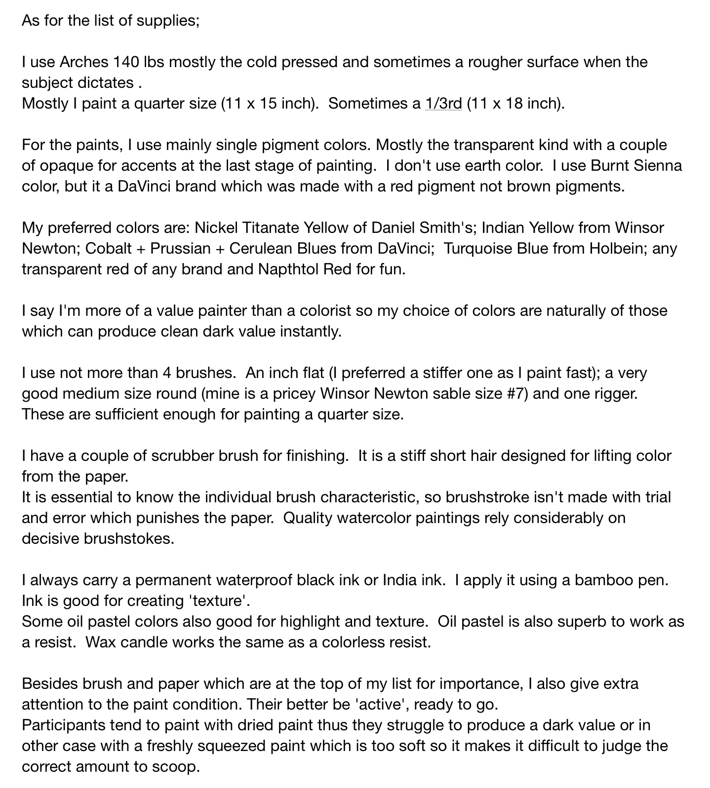
Materials to Create Texture:

A piece of candle for wax resist; salt, oil pastel, sand paper on rough paper, wax paper, razor point for
scraping etc.

